Lesson 2 : CASE STUDY
- Identify business problem, Problem can come from:
  - Upset users or customers
  - sales or customer teams fail to gain customer
  - Lost revenue
  - Grumpy engineers
You can use all those problem as you figure out what need to be build and this known as :
- Product discovery starts with problems
  - The one come with problems also brings in idea
  - Problem makes idea easy and plentiful and cheap
  - Figure out which idea that the team should be investing on
  - Things need to aware , there will be so many idea. So it’s better to bring right teams to analyse on the problem and opportunity
- Protype and impact
  - Need to come up with a prototype so that you know if you’re investing on right product or not
  - Need to look for the one that has the biggest return on investment
  - Recommended to find for a biggest impact least amount of work and to use artificial intelligence to make value even more impactful
- Real-data prototype
  - Build out a small version of your product and see what happens with real, user data
  - It’s totally fine if its ugly or broken
  - Measure twice, cut once
  - Mockup vs prototype vs Wireframe
    - Wireframe: structure and functional requirements (static)
    - Mockup: a wireframe, but with visual design (static)
    - Prototype: a mockup, but with interactions (dynamic)
  - 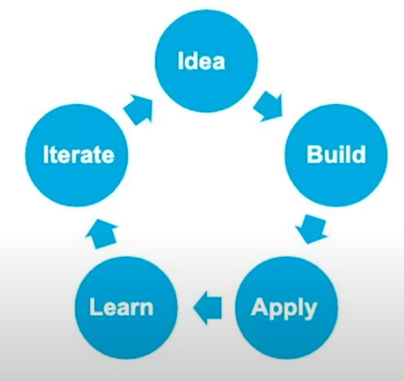
- Test, Refine -> Final product
  - A lot of different kind of testing need to take place, eg : A/B Testing
  - After a bunch of iteration of prototyping and testing we’ll be end up with the final product
- Release, Measure, Update
  - Build the product – should be pretty easy
    - Translate the requirements and do any operational or security updates
    - Instrument updates to measure impact and changes
    - Get it out the product as quickly as possible, don’t block future you(don’t really something you cant iterate on quickly )
  - Launch the product
    - Use the metrics from your testing to help marketing
    - Those upset customers were happy now, get their help
  - React to new information as you release
    - You’ll be swarmed with a deluge of product feedback. Totally normal, and your job then is to react to the new information you’re getting
    - You might miss the edge case scenarios so what you can do now is “Repeat the process but smaller and more quickly”
- Always learning
  - You’ll pretty much never stop being in this process
  - The joys of working in artificial intelligence and machine learning is that the industry moves really quickly.
  - You need to keep on learn so that you manage to react to it and to update what you’re building.

